Edge Intelligence Lab-1

Name: N. Lakshmi Sandeep
Register No: 25MML0006
Tasks:
1. Identify Jupyter Notebook
2. Open Jupyter Notebook
3. Choose a Dataformat
4. Choose a Dataset
5. Load the Dataset

Implementation:
Chosen Image Dataset – animal 10N dataset consists of 5000 images of training data and 5000 images of testing data
By importing deeplake library can load the direct dataset from link

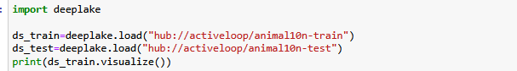

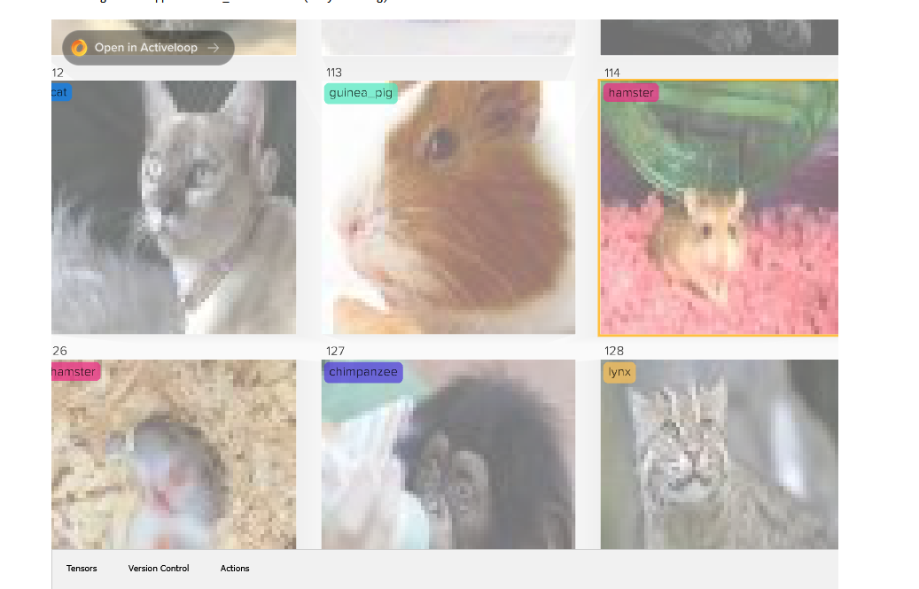
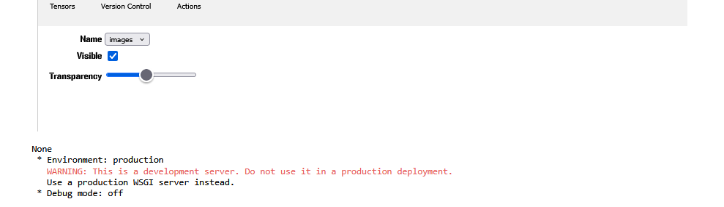
Error:

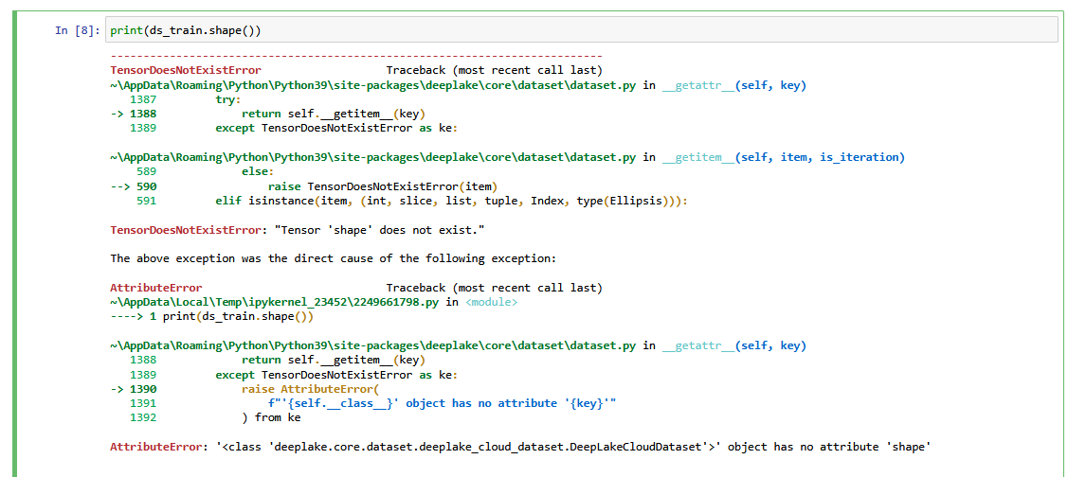

Error can be rectified by including tensor images as ds_train.images.shape
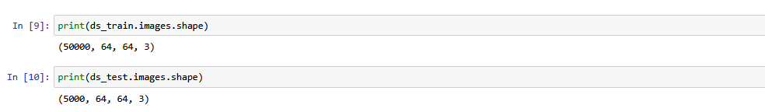

Actually, here all the images having the same shape as we have taken the preprocessed data, suppose if the dataset contains different shapes that means different resolution we have to reshape each image by using opencv, if we take the testing data as example we can reshape each image into
import cv2
import numpy as np
TARGET_SIZE = (224, 224)
resized_images = []
for sample in ds_test:
img = sample['images'].numpy()
img_resized = cv2.resize(img, TARGET_SIZE)
resized_images.append(img_resized)
resized_images = np.array(resized_images)
print(resized_images.shape)

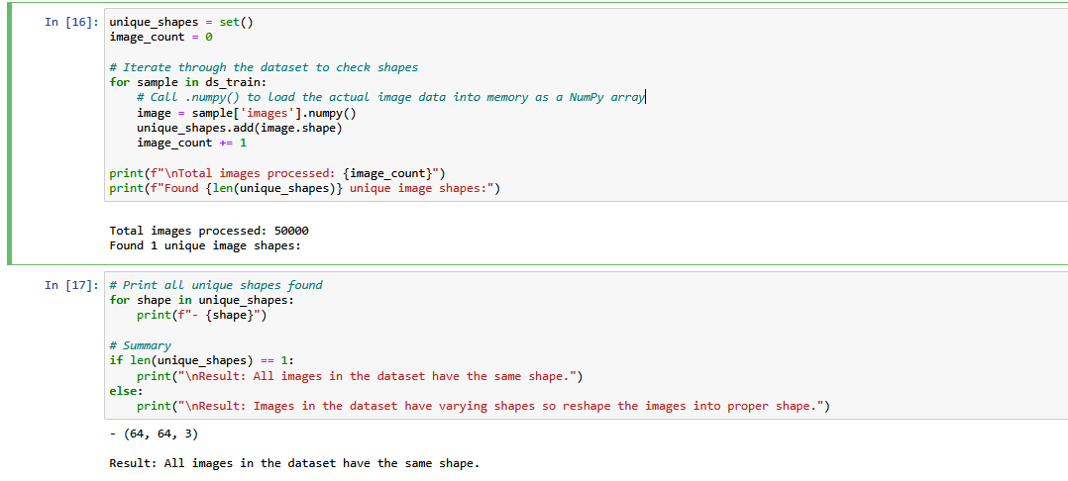

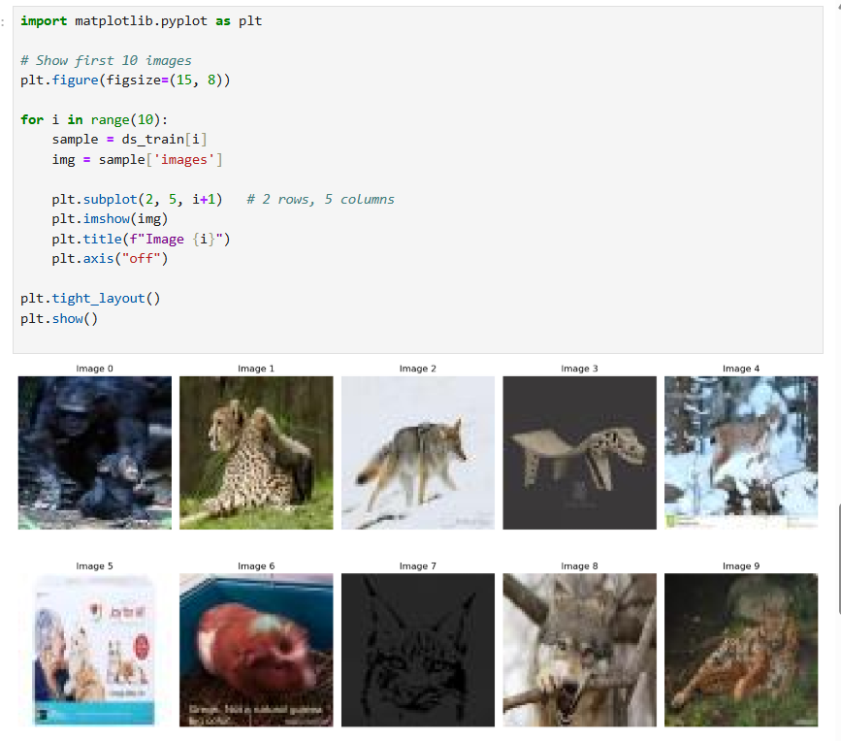
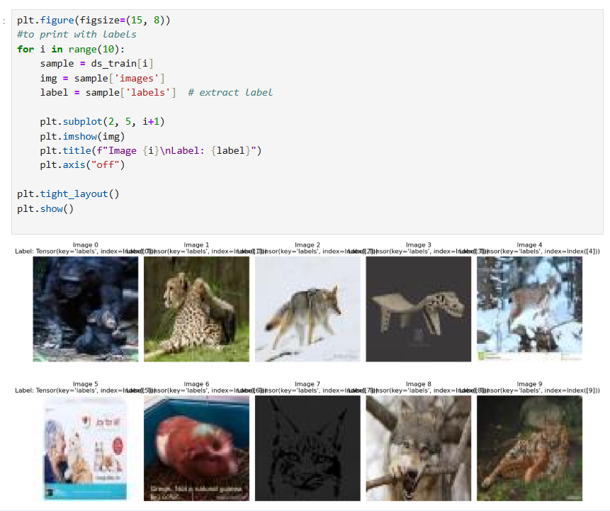
Here we can see an error as all the labels are occurred at once without the specific label so to get that specific label correspond to that image we need to add .numpy() to each sample.

After adding numpy() to the labels
